

Highcliffe School Student Bulletin

Monday 23rd – Friday 27th June 2008: Week B

Thought For The Week:
There is more to life than increasing its speed.
Mahatma Ghandi

News Topic of the Week:
Arctic ice 'melting even faster'
‘See http://news.bbc.co.uk/cbbcnews/hi/sci_tech/default.stm

4:1 Days return this week

Congratulations! Our new Head Girl is Katie Russell, and our new Head Boy is Jamal Al-Sheikhly.
The posts of Deputy Head Girl and Deputy Head Boy are now held by Catherine White and Alex Smith!


Activities week fishing trip: Tuesday 15th July – Year 8 & Year 9. Cost £8.00 – Tuition, tackle and bait provided. Bring a packed lunch and waterproof clothes. Students need to see Mrs Wheeler in the Library and register an interest and those names selected (from a hat) will be notified and given a letter and medical form which must be completed and taken to the Finance Office before Friday 27th June.

Merits: Year 7, 8 & 9 students – only a couple of weeks left to cash in your merits before the final merit assemblies of the year. Look out for Mr. Yapp & his yellow sign on the field at lunchtimes!

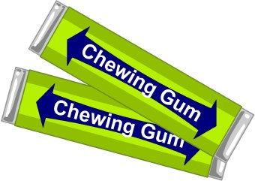
Music notice: Any student who missed an instrument lesson due to an exam or a school trip needs to write their name, tutor group and instrument or trip on a piece of paper and take it up to the Finance Office for Mrs Coomber by the end of the week so that credits may be given for next term. Thank you.

Chewing Gum: a reminder to all students that chewing gum is not allowed in school.

There will be NO ECO CLUB on Tuesday as there is an all staff Science meeting. We will make the bird balls the following week so save your seeds for then!

There is a Year 9 Fundraising Ball meeting in Mr Evans's room on TUESDAY at 8.45am. Bring posters / logos / Powerpoints saved on a memory stick or e-mail to Miss High: lhigh@highcliffe.dorset.sch.uk.

Water fountains are now available around the school for students to use. It is important to drink water regularly especially during hot weather. The water fountains are situated near the dance studio room EX4, on the outside wall from the PE changing rooms and by the quiet area at the front of school. Water bottles can be filled here too.
In The Zone Dance Club Rehearsal: All students who attended dance club last term with the Year 12 Dance Leaders Alex and Katie have an important rehearsal for the Summer Concert on Wednesday (24th June) after school from 3.30pm prompt until 4.30pm.

Fantasy online shares league: Please could all those who have registered to the league please attend an important meeting on Tuesday 24th June, in IT1 at 1.45pm. It will be discuss league positions and progress, and extending the league to other schools.


PE NOTICES –
Year 7 rounders tournament – 2nd
Year 9 & 10 rounders v Wentworth – won
Year 7 cricket v Emmanual – won
Year 9 cricket v Poole Grammar - lost
Year 8 rounders v Poole High - lost

MUSIC NOTICES –
Summer Concert on Wednesday 2nd and Thursday 3rd July…Tickets On Sale NOW!

The Second Round of Auditions for the musical are on Monday after school 3.30pm – 5.30pm in Ex4. Check the list in the corridor to EX3 to see if you have been recalled. A list of all parts will be published on Wednesday in EX3.

The signup sheet for next year’s Highcliffe Talent Show is up in EX3. We are looking for acts with any talent, so come and sign up if you think you’ve got what it takes! All proceeds are for the World Challenge.

Rehearsals for those involved in the Summer Concert…
Shout! – Monday lunchtime 1.40pm in EX3
Vocalis – Wednesday lunchtime 1.40pm in EX3
Guitar Club – Tuesday lunchtime 1.40pm in EX2
Harmonious Funk Jazz band – Wednesdays after school 3.30 – 4.30pm in EX3

EVER WISHED YOU COULD PLAY A MUSICAL INSTRUMENT? IT’S NEVER TOO LATE TO START!

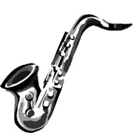
On offer to students of Highcliffe school are lessons on:
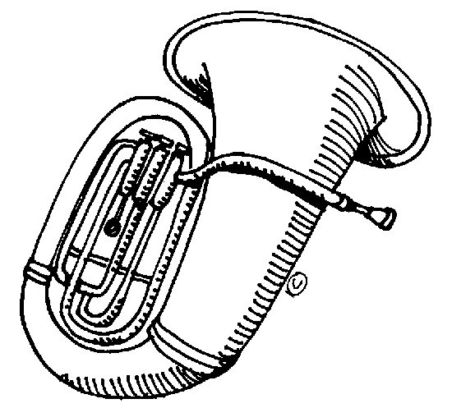
Woodwind: Recorder, Flute, Clarinet, Saxophone
Brass: Trumpet, French Horn, Trombone, Tuba
String: Violin, Viola, Cello, Double Bass
Guitar: Acoustic, Electric, Bass
Other: Drums, Piano, Keyboard, Theory, Voice

SPECIAL PROMOTIONAL OFFER!!
New for 2008 – We are offering FREE instrumental hire for students playing brass and string instruments.

If you are interested in starting a new instrument, please see a member of the music department ASAP for a letter with more details.
Mr Trevorrow

BRAINTEASER –

Last week’s Brain Teaser:
l0l0l0=9:50
Can you make the above statement true by adding just one small line?

The solution is: If you add a line above the second l it becomes l0 T0 l0 = 9:50

Well done to the winner Calum Hind of 73, please come to Miss White in Ma6 to receive your prize.

This week’s Brain Teaser:

How many Alphanumbetical numbers can you find? These are numbers which when written as words have all their letters in alphabetical order.

Answers to be submitted by Friday 4th July with name and tutor group to the brainteaser box in Ma6.

P.E. FIXTURES/PRACTICES

23rd June – 27th June 2008

 | LUNCHTIME | AFTER SCHOOL
Monday | Year 7 Cricket | Year 8 Rounders v Sandford (A)  Year 7 Cricket v Winton (H)
Tuesday | Year 9 Cricket | Year 10 Rounders v BSG (H)  Year 9 Cricket v Twynham (A)
Wednesday | Year 8 Cricket | Year 8 Rounders v Cranbourne (A)
Thursday | Year 10 Cricket | Year10 Rounders v Corfe Hills (A)  Year 7 Rounders v Grange (H)
Friday | Year 10 Rock-it ball

